Dear Applicant
On behalf of the Board of Directors for The Romero Catholic Academy, we would like to thank you for your interest in the post of Teacher of English within our Multi Academy Company.
The closing date for receipt of applications is via email to HR at hr@romeromac.com by Wednesday 14th October 2020.
This letter is intended to help you complete the application form. Please read it carefully before the completion of your application form. If you have any difficulties, please contact HR at hr@romeromac.com
The application form is your opportunity to provide all the information we will require to help us understand how you meet the requirements of the job. Similarly, it plays an important part in the selection process allowing us to short-list candidates for interview and helping as a basis for the interview itself. To ensure fairness to all applicants, short-listing decisions are based solely on the information you supply on your application form. Even if we already know you as a current or previous employee, it is important that you complete the form in full.
All vacancies are accompanied by a job description and a person specification setting out the main duties and responsibilities of the post in the job description, and the knowledge, skills and experience we are looking for in the person specification.
Please read this information carefully as you will not be short-listed for interview unless you meet the essential criteria described in the Person Specification.
Depending on the number and quality of applications, it may not be possible to shortlist for interview all candidates who meet the Essential Criteria. However, we guarantee to interview all disabled applicants who meet the Essential Criteria.
We are unable to accept CVs so please do not attach your CV, references, or copies of educational certificates to your form. If there is insufficient room on the form in a particular section, you can simply attach an extra page and mark it clearly with your name and the job title, indicating the number of the relevant question.
The ‘Relevant skills & experience' section of the form is your opportunity to tell us specifically why you wish to apply and what makes you a suitable applicant. You should include anything you feel would be useful in support of your application telling us as much as possible about yourself in relation to all the items listed in the job description.
Please remember that those involved in the selection process cannot make assumptions about you. - tell us everything relevant to your application and complete all the sections on the form.

Data Protection
Information provided by you as part of your application will be used in the recruitment process. Any data about you will be held securely with access restricted to those involved in dealing with your application and in the recruitment process. Once this process is completed the data relating to unsuccessful applicants will be stored for a maximum of 6 months and then destroyed. If you are the successful candidate, your application form will be retained and form the basis of your personnel record. By signing and submitting your completed application form you are giving your consent to your data being stored and processed for the purposes of the recruitment process, equal opportunities monitoring and your personnel record if you are the successful candidate. Romero Academy reserve the right to check the validity and accuracy of your application if successful.
Equal Opportunities
Information provided by you on the Equal Opportunities Monitoring Form will be used to monitor our equal opportunities policy and practices. This part of the form will be detached from the main body of the application form and will not form any part of the selection process.
Work Permits
Under the Asylum and Immigration Act, we are required to check that anyone taking up employment with us has the legal right to work in the UK. Shortlisted applicants will be asked to provide us with documentary evidence to support their entitlement to work in the UK prior to any offer of employment being made.
DBS Checks
In line with our safeguarding and child protection policy, all employees and volunteers working in specific roles at the Academy will be subject to satisfactory clearance being obtained from the Disclosure and Barring Service. The check will be undertaken as part of the appointment process with the successful candidates. If you are invited to interview, you will be asked to bring this information with you.
PLEASE NOTE We will take up references for all shortlisted candidates prior to interview and reserve the right to validate all information entered on the application form. Please ensure that any person who is asked to act as a Referee knows this information and is available to give a reference during this time.
We expect all our staff and employees to be in sympathy with our Catholic values and help us to achieve the vision that we have set ourselves to work towards.
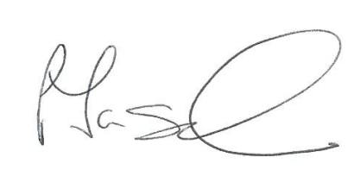

Patrick Taggart
Academy Business Director
The Romero Catholic Academy

The Romero Multi Academy Company
“Securing 3-19 Catholic Education in Coventry”

“This is what we do:
We plant the seeds that one day will grow.
We water seeds already planted, knowing that they hold future promise.
We lay foundations that will need further development.
We provide yeast that produces far beyond our capabilities.”

Each school retains its own unique ethos and mission recognising the local community it serves. However, our unified Mission states that

“We are a Christ-centred Communities dedicated to faith formation, academic excellence and individual growth for our young people, all rooted in the Gospel message of Jesus Christ.”
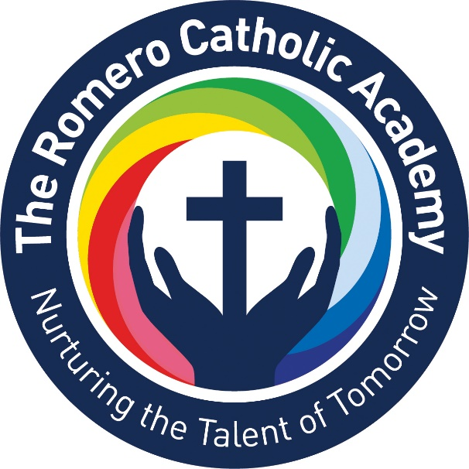

Our Schools

The following schools are within The Romero Catholic Academy:-

Secondary School:-
Cardinal Wiseman Catholic School

Primary Schools:-
Corpus Christi Catholic Primary School
Good Shepherd Catholic Primary School
Sacred Heart Catholic Primary School
St Gregory Catholic Primary School
St John Fisher Catholic Primary School
St Patrick Catholic Primary School
SS Peter and Paul Catholic Primary School

